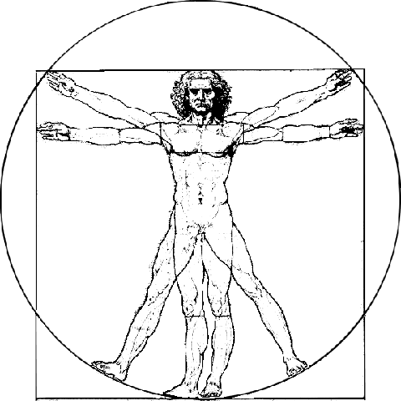
Premier Health Care, LLC
Sean K. Branham, D.C.

LipoLaser/Weight Loss/Detoxification Survey

Today’s date: _______________________
Name: ______________________________ DOB____________ Gender: M/F
Address:____________________________________________________________________
Phone: ______________________________ E-mail: _______________________________
Cell Phone: __________________________ Work Phone:____________________________
Social Security #_______________________ Height_________ Weight____________
Marital Status: Married Separated Divorced Single Widowed
Emergency Contact: _________________________ Phone:___________________________
Occupation: _____________________________ Employer: _________________________
Would you describe your job as: Sedentary Light Activity Moderate Activity Heavy Activity
Are you Pregnant? Y/N Are you breastfeeding? Y/N Do you have a pacemaker? Y/N
Are you happy with your current weight? ___Yes ___No
How much weight would you like to lose? _______________________
Would you be willing to make some lifestyle changes to achieve this weight loss goal?
Yes ________No _________ (Please explain)_______________________________________
____________________________________________________________________________

Do you have any of the following illnesses or symptoms? Answer “yes” or “no.”
Yes/no Yes/no
  Back Pain   Type II Diabetes
  Chemical Sensitivities   High Blood Pressure/Hypertension
  Chronic Fatigue   Heart Disease
  Rashes   Fibromyalgia
  Chronic Headaches   Stroke
  Allergies   Cancer
  Migraine Headaches   Kidney Disease
  Brain Fog/Poor Concentration   Hypothyroidism
  Frequent Colds or Flu   Hashimotos Thyroiditis
  Anxiety   IBS
  Joint Pain   Crohns/IBD
  Cold Hands & Feet   Disc Bulges/Herniations
  Mood Swings   Neuropathies
  Night Sweats   Bloating
  Cellulite   Constipation
  Depression   Abdominal Pain
  Acne   Cramping
  Dark Circles Under the Eyes   Cancer
  Burning Skin   Epilepsy
  Candida   Liver Function
  Poor Dexterity
  Neck Pain
  Diarrhea
Family medical history (list please): _____________________________________________________________________________________

Diet and Lifestyle History: Please check or circle all that apply.
How many meals do you usually eat each day? _________
Do you skip meals? yes/no Times: ____daily/weekly Do you eat out? yes/no Times: ____daily/weekly

Do you exercise? Y/N If so please state what you do and how often: ______________________________________________________________________________

What do you dislike the most about being overweight?
____________________________________________________________________________________________________________________________________________________________

What would be your biggest reason to lose weight?____________________________________________
_____________________________________________________________________________________

How does your weight affect your physical activity?
0 1 2 3 4 5 6 7 8 9 10

How does your weight affect your relationships?
0 1 2 3 4 5 6 7 8 9 10

How does your weight affect your self-esteem?
0 1 2 3 4 5 6 7 8 9 10

How important is it that you achieve and maintain great health?
0 1 2 3 4 5 6 7 8 9 10

What role does excess fat play in your life? How does it put you at risk? Specifically?
____________________________________________________________________________________________________________________________________________________________

What health difficulties are you experiencing that you feel is attributable to being overweight? ____________________________________________________________________________________________________________________________________________________________

Overweight and obesity may increase the risk of many health problems, including diabetes, heart disease and certain cancers.
Do you feel like you are at risk for these diseases?
______________________________________________________________________________

Do you want more than 1 area of circumference reduction? Y/N
Which areas?________________________________
How many inches would you like to lose?_______________________________

Please write down three reasons you would like to lose weight. These shouldn’t be generalizations, but rather personal reasons that actually mean something to you. It is important to list these out as both a guide for us to help you, and motivation for yourself so that you may reach your ideal weight.

__________________________________________________________________________________________________________________________________________________________________________________________________________________________________________

Do you eat meals in your car (e.g. to and/or from work?) Y N Sometimes
List Use of:
Tobacco __Yes ___No If yes, would you like to quit?____Yes ____No
Alcohol __Yes __ No
Caffeine __Yes __ No
Coffee __Yes __ No

Weight History:
Which of the following family members have/had weight control problems?
____Mother ____Father ____Brother/Sister ____Paternal Grandparents
____Maternal Grandparents ____Children

Were you an overweight child? ___Yes ___No

How long do you feel your weight has been a problem? _____________________________________________________________________________________

List any medical problems, injuries, or life events that have significantly affected your weight. Include year and weight change. __________________________________________________________________________________________________________________________________________________________________________

List any medications or diet aids that you have tried for the purpose of losing weight: _____________________________________________________________________________________

In your opinion, what contributes to your excess weight?
___Portion size ___Nervous eating ___Always hungry ___Compulsive eating ___Emotional eating
___Boredom ___Lack of exercise ___Depression ___Eating too much fat/sugar ___Stress

Please list any food allergies or intolerances. __________________________________________________________________________________________________________________________________________________________________________

Have you ever been a binge eater? ___Yes ___No

Have you ever had a bulimia or anorexia disorder? ___Yes ___No

Are you more of a structured eater or a haphazard eater? Circle one. Explain _____________________________________________________________________________________

If it is affordable--would you want to start a weight loss program now? Y/N

AUTHORIZATION FOR THERAPY
I, the undersigned client, hereby authorize Premier Health Care to administer such therapy as is necessary. I hereby certify that I understand the advantages and possible complications. I also certify that no guarantee or assurance has been made as to the results that may be obtained.

Client Print Name_____________________________________ Date________________________

Client Signature______________________________________

Technician Signature___________________________________ Date________________________

