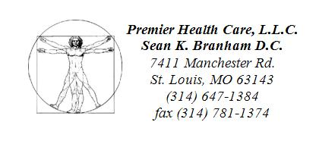

Dear Friend,

You should know that your visit in our practice today is not a sales presentation, there is nothing to buy and you cannot become a patient in our practice today.

Our process for admitting patients is typically a two day process, both of which are complimentary. Your first visit may be in a group setting; we will be giving you valuable health information regarding your specific condition. The second visit is always one on one with a doctor and geared mostly around understanding your individual needs and whether or not you can be admitted as a patient under our care.

Before you see a doctor you will be allowed to view video patient testimonials with the intent of showing what may be possible with your own health should you be a good fit for our practice.

Our practice, due to many factors, mainly our clinical success, has grown to levels where we cannot possibly see every potential patient one on one for both visits. If you are uncomfortable with this process then simply make our front desk aware and we will attempt to accommodate your needs at another time.

Warmly,

Dr. Sean Branham, D.C.

