Please Read: This questionnaire is designed to enable us to understand how much your low back has affected your ability to manage everyday activities. Please answer each Section by circling the ONE CHOICE that most applies to you. We realize that you may feel that more than one statement may relate to you, but Please just circle the one choice which closely describes your problem right now.

SECTION 1--Pain Intensity
- The pain comes and goes and is very mild.
- The pain is mild and does not vary much.
- The pain comes and goes and is moderate.
- The pain is moderate and does not vary much.
- The pain is severe but comes and goes.
- The pain is severe and does not vary much.

SECTION 2--Personal Care
- I would not have to change my way of washing or dressing in order to avoid pain.
- I do not normally change my way of washing or dressing even though it causes some pain.
- Washing and dressing increase the pain, but I manage not to change my way of doing it.
- Washing and dressing increase the pain and I it necessary to change my way of doing it.
- Because of the pain, I am unable to do any washing and dressing without help.
- Because of the pain, I am unable to do any washing or dressing without help.

SECTION 3--Lifting
- I can lift heavy weights without extra pain.
- I can lift heavy weights, but it causes extra pain.
- Pain prevents me from lifting heavy weights off the floor.
- Pain prevents me from lifting heavy weights off the floor, but I can manage if they are conveniently positioned, e.g. on the table.
- Pain prevents me from lifting heavy weights , but I can manage light to medium weights if they are conveniently positioned.
- I can only lift very light weights, at the most.

SECTION 4 --Walking
- Pain does not prevent me from walking any distance.
- Pain prevents me from walking more than one mile.
- Pain prevents me from walking more than one mile.
- Pain prevents me from walking more than 1/2 mile.
- I can only walk while using a cane or on crutches.
- I am in bed most of the time and have to crawl to the toilet.

SECTION 5--Sitting
- I can sit in any chair as long as I like without pain.
- I can only sit in my favorite chair as long as I like.
- Pain prevents me from sitting more than one hour.
- Pain prevents me from sitting more than 1/2 hour.
- Pain prevents me from sitting more than ten minutes.
- Pain prevents me from sitting at all.
DISABILITY INDEX SCORE: %
SECTION 6 -- Standing
- I can stand as long as I want without pain
- I have some pain while standing, but it does not increase with time.
- I cannot stand for longer than one hour without increasing pain.
- I cannot stand for longer than ½ hour without increasing pain.
- I can’t stand for more than 10 minutes without increasing pain.
- I avoid standing because it increases pain right away.

SECTION 7--Sleeping
- I get no pain in bed.
- I get pain in bed, but it does not prevent me from sleeping.
- Because of pain , my normal night’s sleep is reduced by less than one-quarter.
- Because of pain, my normal night’s sleep is reduced by less than one-half.
- Because of pain, my normal night’s sleep is reduced by less than three-quarters.
- Pain prevents me from sleeping at all.

SECTION 8--Social Life
- My social life is normal and gives me no pain.
- My social life is normal, but increases the degree of my pain.
- Pain has no significant effect on my social life apart from limiting my more energetic interests, e.g., dancing, etc.
- Pain has restricted my social life and I do not go out very often.
- Pain has restricted my social life to my home.
- Pain prevents me from sleeping at all.

SECTION 9--Traveling
- I get no pain while traveling.
- I get some pain while traveling, but none of my usual forms of travel make it any worse.
- I get extra pain while traveling, but it does not compel me to seek alternative forms of travel.
- I get extra pain while traveling which compels me to seek alternative forms of travel.
- Pain restricts all forms off travel.
- Pain prevents all forms of travel except that done lying down.

SECTION 10--Changing Degree of Pain
- My pain is rapidly getting better.
- My pain fluctuates, but overall is definitely getting better.
- My pain seems to be getting better, but improvement is slow at present.
- My pain is neither getting better nor worse.
- My pain is gradually worsening.
- My pain is rapidly worsening.

THE REVISED OSWESTRY PAIN QUESTIONNAIRE
NAME DATE
How long have you had back pain years months weeks
On the diagram below, please indicate where you are experiencing pain, right now. Please complete both sides of this form.
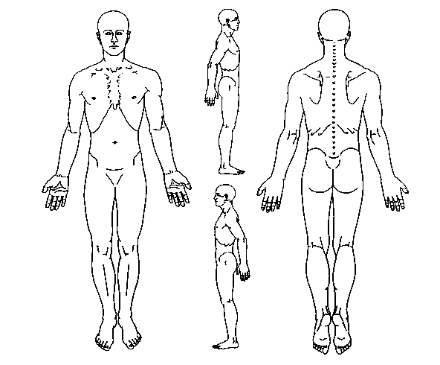
A = ACHE
P = PINS & NEEDLES
B = BURNING
S = STABBING
N = NUMBNESS
O = OTHER

