Please Read: This questionnaire is designed to enable us to understand how much your neck pain has affected your ability to manage everyday activities. Please answer each Section by circling the ONE CHOICE that most applies to you. We realize that you may feel that more than one statement may relate to you, but Please just circle the one choice which closely describes your problem right now.

SECTION 1--Pain Intensity
- I have no pain at the moment
- The pain is mild at the moment.
- The pain comes and goes and is moderate.
- The pain is moderate and does not vary much.
- The pain is severe but comes and goes.
- The pain is severe and does not vary much.

SECTION 2--Personal Care (Washing, Dressing etc.)
- I can look after myself without causing extra pain.
- I can look after myself normally but it causes extra pain.
- It is painful to look after myself and I am slow and careful.
- I need some help, but manage most of my personal care.
- I need help every day in most aspects of self-care.
- I do not get dressed, I wash with difficulty and stay in bed.

SECTION 3--Lifting
- I can lift heavy weights without extra pain.
- I can lift heavy weights, but it causes extra pain.
- Pain prevents me from lifting heavy weights off the floor but I can if they are conveniently positioned, for example on a table.
- Pain prevents me from lifting heavy weights, but I can manage light to medium weights if they are conveniently positioned.
- I can lift very light weights.
- I cannot lift or carry anything at all.

SECTION 4 --Reading
- I can read as much as I want to with no pain in my neck.
- I can read as much as I want with slight pain in my neck.
- I can read as much as I want with moderate pain in my neck.
- I cannot read as much as I want because of moderate pain in my neck.
- I cannot read as much as I want because of severe pain in my neck.
- I cannot read at all.

SECTION 5--Headache
- I have no headaches at all.
- I have slight headaches which come infrequently.
- I have moderate headaches which come in-frequently.
- I have moderate headaches which come frequently.
- I have severe headaches which come frequently.
- I have headaches almost all the time.

SIGNATURE: DATE:

DISABILITY INDEX SCORE: %

SECTION 6 -- Concentration
- I can concentrate fully when I want to with no difficulty.
- I can concentrate fully when I want to with slight difficulty.
- I have a fair degree of difficulty in concentrating when I want to.
- I have a lot of difficulty in concentrating when I want to.
- I have a great deal of difficulty in concentrating when I want to.
- I cannot concentrate at all.

SECTION 7--Work
- I can do as much work as I want to.
- I can only do my usual work, but no more.
- I can do most of my usual work, but no more.
- I cannot do my usual work.
- I can hardly do any work at all.
- I cannot do any work at all.

SECTION 8--Driving
- I can drive my car without neck pain.
- I can drive my car as long as I want with slight pain in my neck.
- I can drive my car as long as I want with moderate pain in my neck.
- I cannot drive my car as long as I want because of moderate pain in my neck.
- I can hardly drive my car at all because of severe pain in my neck.
- I cannot drive my car at all.

SECTION 9--Sleeping
- I have no trouble sleeping
- My sleep is slightly disturbed (less than 1 hour sleepless).
- My sleep is mildly disturbed (1-2 hours sleepless).
- My sleep is moderately disturbed (2-3 hours sleepless).
- My sleep is greatly disturbed (3-5 hours sleepless).
- My sleep is completely disturbed (5-7 hours sleepless).

SECTION 10--Recreation
- I am able engage in all recreational activities with no pain in my neck at all.
- I am able engage in all recreational activities with some pain in my neck.
- I am able engage in most, but not all recreational activities because of pain in my neck.
- I am able engage in a few of my usual recreational activities because of pain in my neck.
- I can hardly do any recreational activities because of pain in my neck.
- I cannot do any recreational activities all all.

© Vernon H and Hagino C, 1991
(with permission from Fairbank J)

THE NECK DISABILITY INDEX QUESTIONNAIRE
NAME DATE
How long have you had neck pain years months weeks
On the diagram below, please indicate where you are experiencing pain or other symptoms, right now. Please complete both sides of this form.
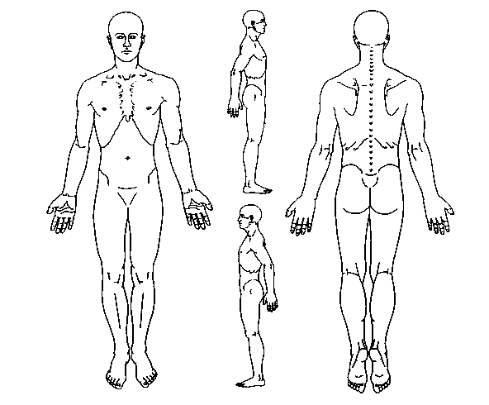

A = ACHE
P = PINS & NEEDLES
B = BURNING
OVER PLEASE ⇒
S = STABBING
N = NUMBNESS

O = OTHER

